Name:

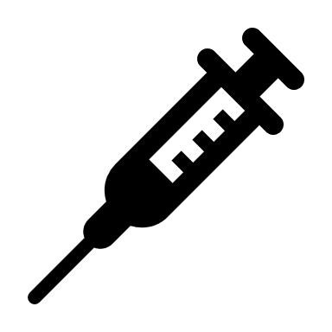 | Polio Eradication  Student Data Collection Sheet

Think About It! Write your answers below:
Understanding Polio   | - How does the poliovirus’s choice of host make it an easy target for eradication?
 | - What jobs and skills would be needed to stop a disease from spreading?
 | - Polio mainly affects children. How does that affect the public’s interest in stopping the spread of the poliovirus?

Polio and  CDC | - Why might people be reluctant to be vaccinated?
 | - How many years have passed since the disease was endemic in the U.S.?
 | - How does vaccination help limit the spread of polio?
In this step, you share your information. Sharing the information you collect is key. Click the links below to share:
https://observer.globe.gov/do-globe-observer/mosquito-habitats
http://www.citizenscience.us/imp/collectionform.php

Call to  Action | - What role does global politics play in public health?
 | - Explain the important role communication plays in vaccination initiatives.
 | - How can your efforts support the efforts of CDC and GPEI?

Design and Build the Vaccine Carrier: Vaccine Carrier Diagram
Draw a diagram of your design in the box below. Make sure to include materials and measurements.

Test the Vaccine Carrier: Data Collection
Time  ( ) | Temperature  ( ) | Use Excel, Sheets, or other graphing tool to graph your data and paste it here. Don’t forget to title your graph and label your axes, including units of measurement.

Reflections
Now that you have built a model and shared your findings, think about what you learned about polio. Answer the questions below.

- What is the poliovirus and how is it transmitted?

- What are the symptoms and consequences of polio?

- What are some challenges communities might experience in accessing proper sanitation and vaccination?

- Health equity is achieved when every person has the opportunity to attain his or her full health potential and no one is disadvantaged from achieving this potential because of social position or other socially determined circumstances. What are some of the health equity issues surrounding polio?

- Before he was president, Franklin D. Roosevelt was diagnosed with polio in 1921 at the age of 39, resulting in permanent paralysis of his legs. He founded the National Foundation for Infantile Paralysis in 1938 to study the disease. How do you think this changed history?

- Why is it important to raise awareness about global public health?

